W8 PRACTICE
Navigation & Async, HTTP

 Learning objectives
- Navigate between tabs
- Navigate with routes
- Input validation and error messages

- Handle Asynchronous call
- Manage the 3 states of a Future within a stateful widget
- Connect the app to a REST API

How to submit?
- Push your final code on your GitHub repository
- Then attach the GitHub path to the MS Team assignment and turn it in

 Before practice, to be prepared!
Read the following documentation to be ready for this practice:

Use a List View
Render widgets conditionally

Lifting state up
Work with outlined buttons

EX 1 – Navigate between tabs

💡Start code provided

For this exercise, we need to navigate between 3 tabs (red, blue, green)
- Each of them is accessed within its icon on the BottomAppBar.

CONSTRAINTS
- Create an enum to handle the 3 types of tabs
- Convert the App screen to stateful to handle the current displayed tab
- Add getters to provide the current displayed tab
- Add call back functions to switch tabs

TIP
Render widgets conditionally
Bottom navigation bar

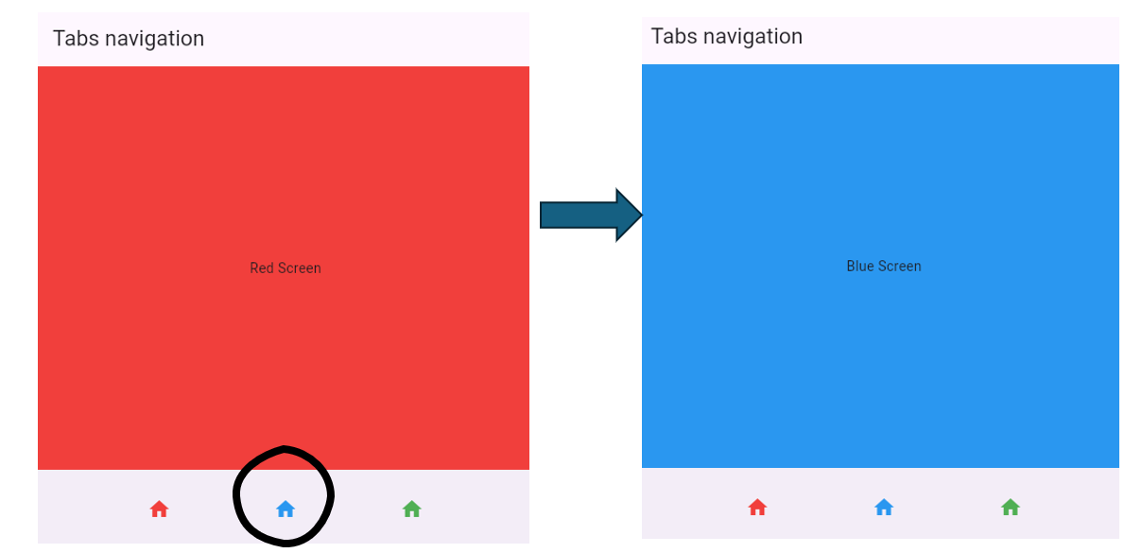

EX 2 – Navigate with routes

💡Start code provided

For this exercise, we need to navigate between 3 screens (forward + backward).

- The 2 first screens are already provided
- You need to complete the last screen

TIP
https://docs.flutter.dev/ui/navigation

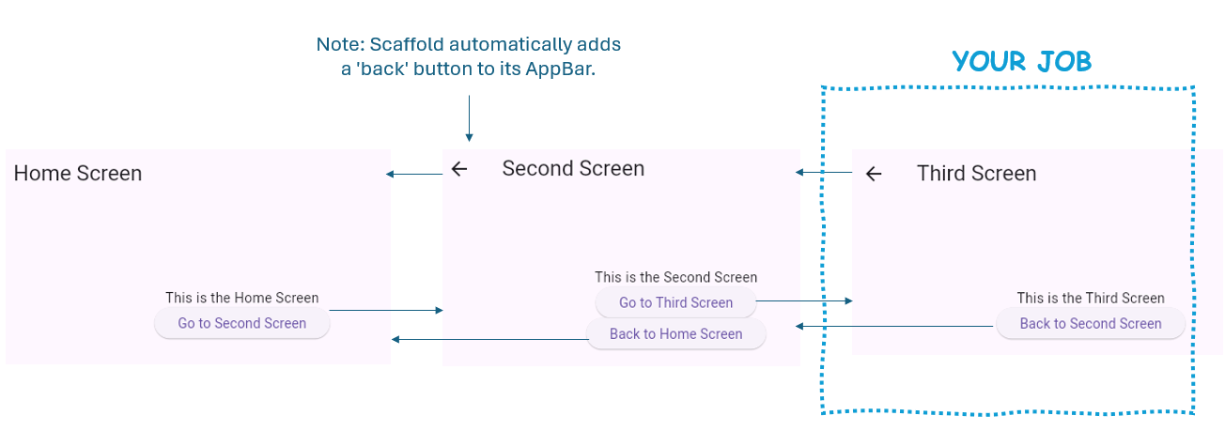

CONSTRAINTS

- You need to use Navigator PUSH and POP methods to switch between screens

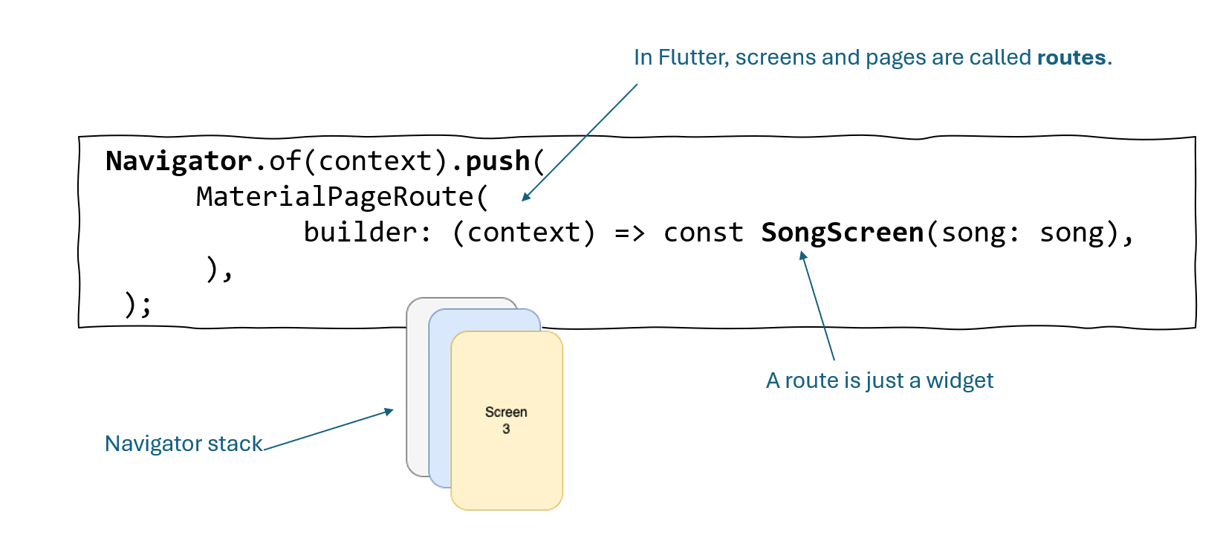

EX 3 – Improve the Expense Form

💡Start code provided

For this exercise, we need to

- Display the Expense Form using a Route (Navigator.push) rather than a modal.

- When a quantity is not a number or if the quantity if not in the range 0 to 100, display a RED error message

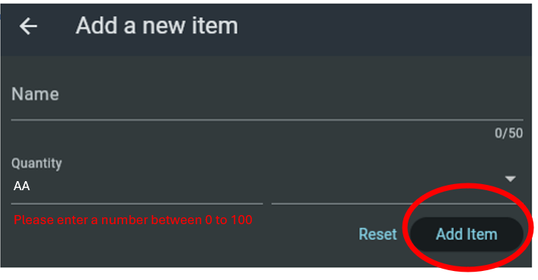

💡When to handle the error message display?

- Option1 : Upon any character typed on the textfield
- Option 2 : after the user pressed on Add Item button

You are free to choose between those 2 options !

However, you must justify your choice of handling the TextField value either
- through state management
- or a TextEditingController.

EX 4– Handle Asynchronous calls

💡Start code provided

For this exercise, we need to update the existing code fetch a list of expenses from the repository

- On the repository, change the fetchExpense to return a Future<List<Expense>> after 5 seconds

- Update the test code to print the list of Expense on console after 5 seconds

- Update the UI to keep the list of Expense as a state: List<Expense>? expenses.

- Update the UI to handle the list of Expense using a ListView (get content method)

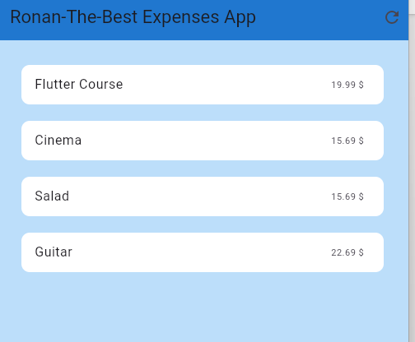

EX 5 – Fetch a Single Object from a REST API
CONSOLE BASED EXERCICE

💡Start code provided

In the start code, we retrieve a list of products from a REST API and convert the first product into a Product object.

Let’s explain the code, step by step.

Step 1 – Create the API URL
Uri url = Uri.parse('https://fooapi.com/api/products');
This creates the URL that will be requested.

Step 2 – Send the HTTP Request
Response response = await http.get(url);
The application sends a GET request to the server and waits for the response.

Step 3 – Check the Response Status
if (response.statusCode != 200) {
throw Exception('Failed to fetch products');
}
A successful request should return the code 200.

Step 4 – Convert JSON Text into Dart Objects
Suppose the API returns:

{
"data": [
{
"title": "Coffee",
"price": 2.5
}
]
}

The JSON string is converted into Dart structures:
Map<String, dynamic> json = jsonDecode(response.body);

Step 5 – Extract the Data
List<dynamic> jsonItems = json[“data”];
Map<String, dynamic> jsonItem = jsonItems[0];
Here we retrieve the first product from the list.

Step 6 – Create a Dart Object
Product product = Product.fromJson(jsonItem);

The JSON data is converted into a Product instance, using the bellow method from Product class:

static Product fromJson (Map<String, dynamic> json) {
const String titleKey = 'title';
const String priceKey = 'price';

assert(json[titleKey] is String);
assert(json[priceKey] is double);

String title = json[titleKey];
double price = json[priceKey];

return Product(title: title, price: price);
}

Your turn !
For this exercise, you need to update the existing code and fetch a user, from the given rest API
https://jsonplaceholder.typicode.com/users/1

Follow the same step as explained:

1. Create a User class

2. Implement User.fromJson()
Create a static method that converts a JSON map into a User.

3. Fetch the User

- Create the API URL.
- Send an HTTP GET request.
- Check that the status code is 200.
- Parses the JSON response.
- Create a User object using User.fromJson().

